Feasibility Report

“Deliver My Grocery”



Project By
Zeeshan Zafar
FA14-BSE-011
Yousaf Munir
FA14-BSE-035
Hafiz Muhammad Huzaifa Noor
SP14-BSE-032

Supervised by
Sir Ashfaq Ahmed
Table of Content

1. Title: "Deliver My Grocery" 3
2. Functional Requirements: 3
2.1. Admin Module 3
2.2. Store Module 3
2.3. Delivery Agent Module 3
2.4. Customer Module 3
3. Feasibility Analysis: 4
3.1. Technical Feasibility: 4
3.2. Financial Feasibility: 4
3.3. Resource Feasibility: 5
3.4. Schedule feasibility: 5
3.5. Operational Feasibility: 5
4. Assumptions: 5

- Title: "Deliver My Grocery"

- Functional Requirements:
  - Admin Module
- The admin is the core module that will be able to add, delete, update the product list for the grocery.
- The admin will be able to login and will be able to update their profile information.
- Admin will be able to approve the request of the new delivery agents.
- Admin will be able to monitor all the transaction between customers and delivery agents.
- Admin will be able to block the customer and agent if anyone violate the rules.
- Admin will be able to see the location of the agents on GIS map.
- Admin will be able to point new store on GIS map.
- Admin will be able to add categories for the grocery.
- Admin will be able to see the profile of customer and delivery agent.
- Admin will be able to see the ratings of customer and delivery agent.
- Admin will be able to see the notification place by customer.
- Admin will be able to see the sales of each shop.
  - Store Module
- The store agent will be able to see the product list of the new order.
- The store agent will be able to view the delivery agent on GIS map.
- The store agent will be able to login and logout.
- Store agent will be able to select the language, Urdu or English.
  - Delivery Agent Module
- Agent will be able to login and logout.
- Agent will be able to select the language, Urdu or English.
- Agent will be able to update their profile information.
- Agent will be able to send the image of the grocery to the related customer.
- Agent will be able to rate the customer.
- The agent will be able to see the location of the customer on GIS map.
- The agent will be able to see the store location on GIS map.
  - Customer Module
- Customer will be able to login and logout.
- The customer will be able to select the language, Urdu or English.
- Customer will able to select the categories for the grocery.
- Customer will be able to search for the grocery.
- Customer will be able to select the quantity and weight of the grocery items.
- Customer will be able to view cart.
- Customer will check out the cart and then the request will be send to the central system.
- Customer will have an emergency delivery option.
- Customer will be able to cancel the order if not picked by the agent.
- The customer will be able to update their profile information.
- Customer will be able to see the image and respond accordingly (yes, no).
- The customer will be able to rate the agent and store.
- Customer will be able to contact or send notification to the support center.
- Feasibility Analysis:
An overall study of the project has been carried out and the findings have been listed in this report. The feasibility of “Deliver My Grocery” can be ascertained on the following assessments:
- Technical feasibility
- Financial feasibility
- Resources feasibility
- Schedule feasibility
- Operational feasibility

  - Technical Feasibility:
Feasibility of technology aspect and Data set:
- Android Studio, to build all android base modules.
- SQLite, the database for android application.
- MySQL, the database for desktop/server application.
- QGIS, for android and desktop/server base GIS.
- Eclipse, to build desktop/server base module.
- Medium Specs Laptop or PC with minimum 8GB RAM.
- Linux OS, better runs Android Studio.
- Smartphone, with minimum Android 6 for QGIS.
  - Financial Feasibility:
The Feasibility of financial aspects e.g. pricing and source of availability and financing of tools and other resources required for the project. Provide a tabulated information in the given format:
Resource Name  [hardware or software] | Price  [Monetary cost] | Source  [website URL/Dealer's address etc.]
Android Studio | $ 0 (Free) | https://developer.android.com/studio/index.html
MySQL | $ 0 (Free) | https://www.mysql.com/downloads/
Eclipse | $ 0 (Free) | https://www.eclipse.org/downloads/?
Smartphone | $ 0 (Free) | Locally Available
Medium Specs PC or Laptop | $ 400.00 | Locally Available
QGIS | $ 0 (Free) | http://www.qgis.org/en/site/forusers/download.html
Sponsors/ Funding sources | Self.

  - Resource Feasibility:
- Laptop/ PC are locally available.
- Other resources are available online.
  - Schedule feasibility:
Gantt chart that show sequence of all activities of the project with respect to time.
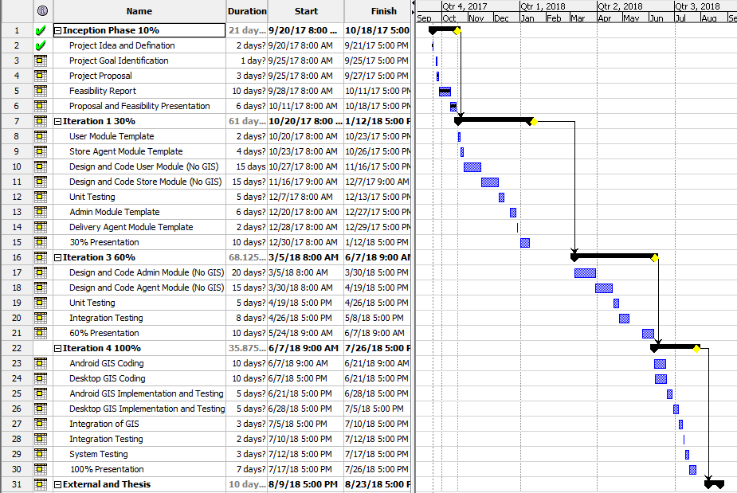
  - Operational Feasibility:
The project contains android emulation and real world implementation of android modules but with given assumptions.
- Assumptions:
The project will work in presence of Wi-Fi technology, the Grocery Store is assuming to contain all the item listed by the admin, and the central to which all device will communicate will be laptop.

